24. Open Hungarian Concept2 Ergometer Championships
Győr, 1 March 2014

General Information:
Date: 1 March 2014
Venue: Győr City University Sports Hall (1 Egyetem Square, Győr 9026, Hungary)
GPS coordinates: Latitude: 47°41´36.58´´
Longitude: 17°37´43.26´´

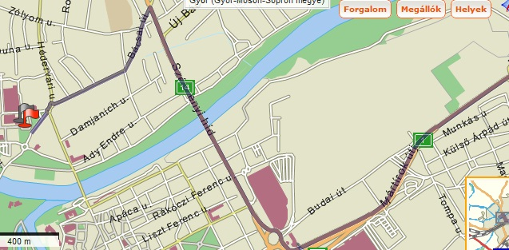

Organisers: Hungarian Rowing Association
Vízisport Csodasport Kft.
Győri Vízügy Spartacus Rowing Club
Hungarian University Sports Federation
Telephone: +36 1 460 68 56
Fax: +36 1 460 68 58
E-mail: info@hunrowing.hu
Web: www.hunrowing.hu

Entries: Entries should be made by filling in the attached entry form (all fields marked with *must be filled). The entries should be sent electronically to the nevezes@hunrowing.hu e-mail address.
Entry Deadline: 19 February 2014 15:00 hrs
Entry Fee:
10 EUR – individual events
20 EUR – team events
The entry fee should be paid in cash at registration before 9:00 on 1 March 2014

Late entries: Late entries will be accepted before the official Team Managers Meeting subject to the available places in the given race. The entry fee will be doubled for these entries.

The Draw: 15:00 19 February 2014
Team Managers Meeting: 9:00 1 March 2014 at the venue

Medals:
I-III. placed athletes will receive medals in each event.
In the Masters category medals will be awarded in each age category if there are at least three entries in the category. If less than three entries are received the category will e combined with the next age group and a time credit system applied.

The programme including start times and start lists will be available on the www.hunrowing.hu website from 24 February.

Events
Number | Event | Distance
1. | Para-rowing for physically disabled (Men, Women AS, TA, LTA) | 1000 m
2. | Para-rowing for intellectually disabled (Men, Women) | 1000 m
3. | Lightweight Women | 2000 m
4. | Open Women | 2000 m
5. | Lightweight Men | 2000 m
6. | Lightweight U23 Men | 2000 m
7. | Open Men | 2000 m
8. | U23 Men | 2000 m
9. | Junior Lightweight Women | 2000 m
10. | Junior Women | 2000 m
11. | Junior Lightweight Men | 2000 m
12. | Junior men | 2000 m
13. | Junior B Women | 2000 m
14. | Junior B U16 Women | 2000 m
15. | Junior B Men | 2000 m
16. | Junior B U16 Men | 2000 m
17. | Masters Men/Women A-J | 1000 m
18. | University Women | 2000 m
19. | University Men | 2000 m
20. | University Team (team of four, min. 1 woman) | 500 m
21. | Teams (team of four irrespective of male/female ratio and age) | 500 m

Regulations:
- Weighing in is compulsory for each participant.
- Time frame for weighing in: from 2 hours before the start time of the heat to 30 minutes before the start time of the relevant heat.
- Someone being late at the start will result in automatic exclusion from that event.
- In case you give up your race there is no second chance to restart.
- All competitors must present a medical certificate stating that they are in physical condition to compete in races, or prove affiliation to their national rowing federation. In absence of the certificate competitors are required to sign a declaration stating that they take responsibility for their physical condition. Indoor rowing racing requires maximal effort and the organizers take no responsibility for illness or injury caused as a consequence. If you have any doubts you should seek medical advice before racing.
- In case of a false start the heat will be restarted only once. In case of the second false start the heat will be not restarted, the athlete(s) that has(have) made the false start will be excluded.
- Time for the medal ceremonies will be determined in the programme published after the draw.
- Weight limits for the lightweight:
Senior Junior
Men: 75 kg 70 kg
Women: 61,5 kg 59 kg

Age groups:
age year of birth
Junior B – U16 15 years 1999
Junior B 16 years 1998
Junior 17-18 years 1996-1997
U23: 19-22 years 1992-1995
Senior above 18 years born in 1995 or earlier
Masters A min. 27 years 1979-1986
Masters B 36 years 1972-1978
Masters C 43 years 1965-1971
Masters D 50 years 1960-1964
Masters E 55 years 1955-1959
Masters F 60 years 1950-1954
Masters G 65 years 1945-1949
Masters H 70 years 1940-1944
Masters I 75 years 1935-1939
Masters J 80 years or more born in 1934 or earlier

For further information please contact the Hungarian Rowing Association.
Contacts:
E-mail: info@hunrowing.hu
Tel: +36 1 460 68 56
The organisers look forward to welcoming you at the event in Győr!

